**AI PROJECT WITH PYTHON**

**ON**

**SENTIMENT ANALYSIS REPORT**

**USING TWITTER**



11804391 - Amar Kant Sonkar ANKITA WADHAWAN

11801422 - Subhajit Payra

11804372 - Nitin Kumar

11815050 - Santosh Mahato

***PRODUCT POPULARIY GROWTH USING TWITTER***

***SENTIMENT ANALISIS***

School of Computer Science and Engineering

Lovely Professional University

**INTRODUCTION**

**Sentiment Analysis**: -

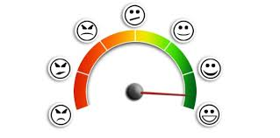Sentiment analysis (also known as opinion mining or emotion AI) refers to the use of [natural language processing](https://en.wikipedia.org/wiki/Natural_language_processing), [text analysis](https://en.wikipedia.org/wiki/Text_analytics), [computational linguistics](https://en.wikipedia.org/wiki/Computational_linguistics), and [biometrics](https://en.wikipedia.org/wiki/Biometrics) to systematically identify, extract, quantify, and study affective states and subjective information. Sentiment analysis is widely applied to [voice of the customer](https://en.wikipedia.org/wiki/Voice_of_the_customer) materials such as reviews and survey responses, online and social media, and healthcare materials for applications that range from [marketing](https://en.wikipedia.org/wiki/Marketing) to [customer service](https://en.wikipedia.org/wiki/Customer_relationship_management) to clinical medicine.

A basic task in sentiment analysis is classifying the polarity of a given text at the document, sentence, or feature/aspect level—whether the expressed opinion in a document, a sentence or an entity feature/aspect is positive, negative, or neutral.

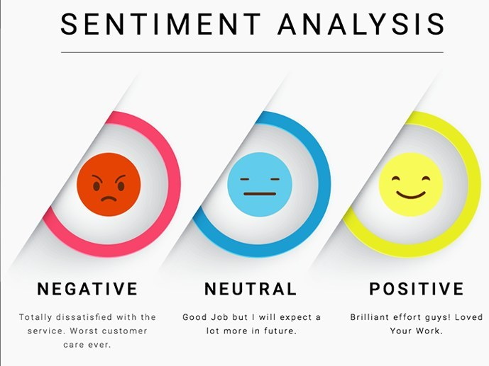

* **Methodology for Analyzing Sentiment**: -

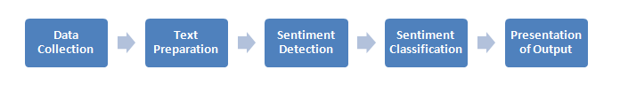

1. Data Collection: -

Consumers usually express their sentiments on public forums like the blogs, discussion boards, product reviews as well as on their private logs – Social network sites like Facebook and Twitter. Opinions and feelings are expressed in different way, with different vocabulary, context of writing, usage of short forms and slang, making the data huge and disorganized. Hence, we will use twitter API’s to extract these data.

1. Text Preparation: -

Text preparation is nothing but filtering the extracted data before analysis.  It includes identifying and eliminating non-textual content and content that is irrelevant to the area of study from the data.

1. Sentiment Detection: -

At this stage, each sentence of the review and opinion is examined for subjectivity. Sentences with subjective expressions are retained and that which conveys objective expressions are discarded. Sentiment analysis is done at different levels using common computational techniques like Unigrams, lemmas, negation and so on.

1. Sentiment Classification: -

Sentiments can be broadly classified into two groups, positive and negative. At this stage of sentiment analysis methodology, each subjective sentence detected is classified into groups – ‘positive’, ‘negative’ and ‘neutral’.

1. Presentation of Output: -

The main idea of sentiment analysis is to convert unstructured text into meaningful information. After the completion of analysis, the text results are displayed on graphs like pie chart.

**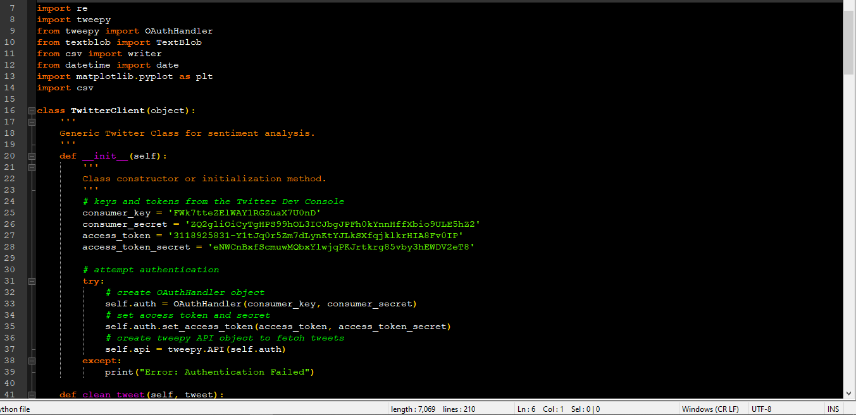CODE-SNIPPET: -**

**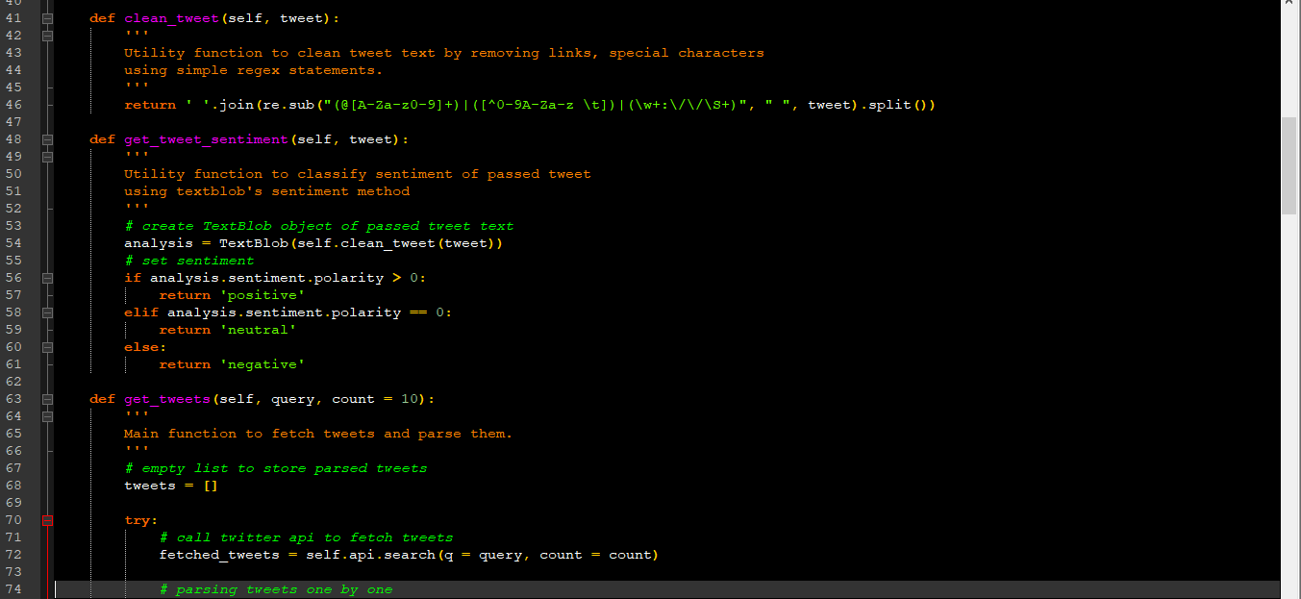**

**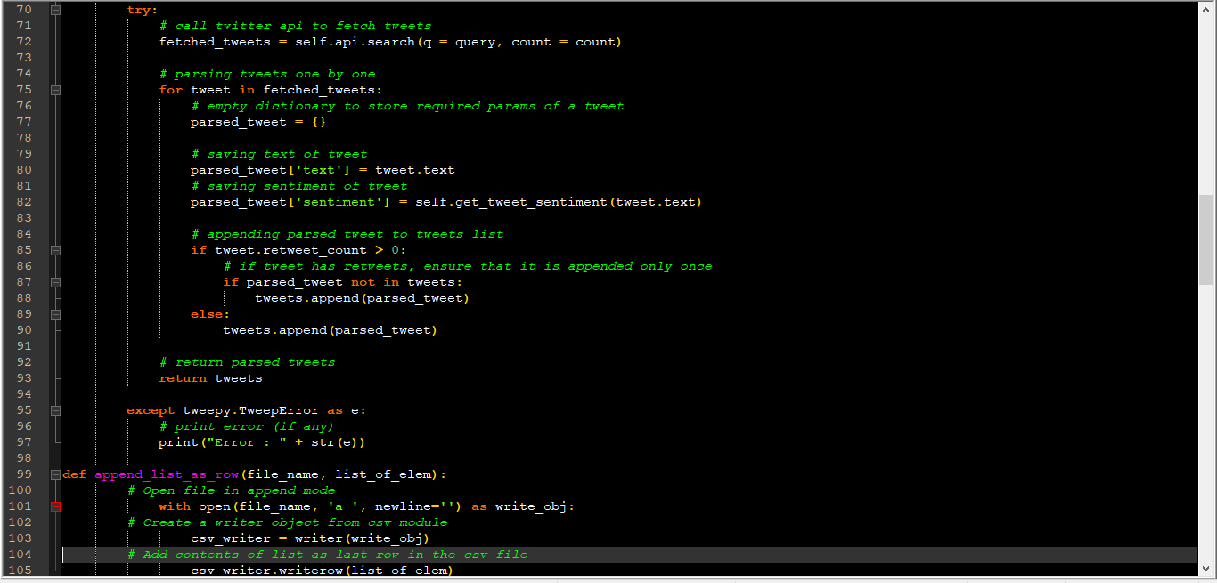**

**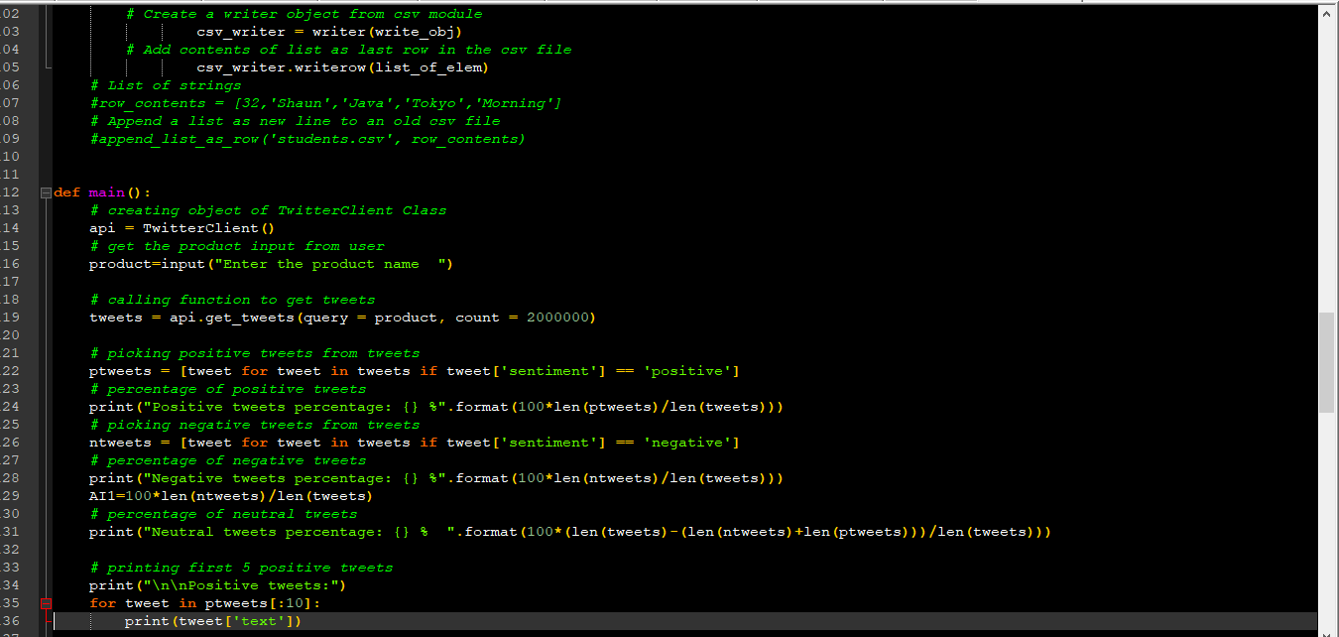**

**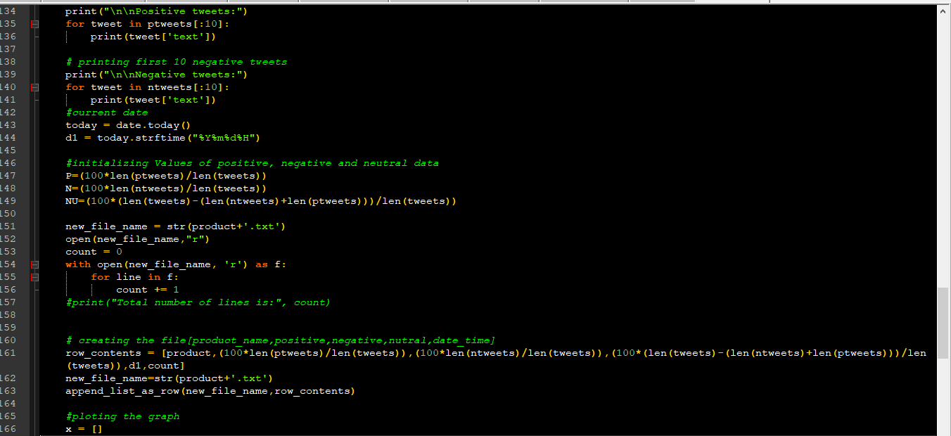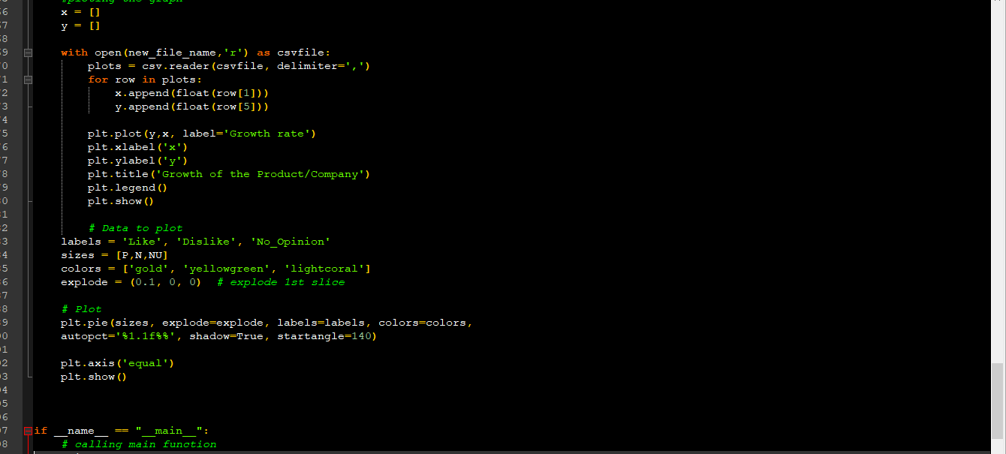**

**Some Python library with its use: -**

**Tweepy:** - Tweepy is a Python library for accessing the Twitter API. It is great for simple automation and creating twitter bots. Tweepy has many features. Like Get tweets from our timeline, Creating and deleting Tweets, Follow and unfollow users.

**Textblob:** -**TextBlob** is a **Python** (2 and 3) **library** for processing textual data. It provides a simple API for diving into common natural language processing (NLP) tasks such as part-of-speech tagging, noun phrase extraction, sentiment analysis, classification, translation, and more.

**Csv:** - **CSV** (Comma Separated Values) is a simple file format used to store tabular data, such as a spreadsheet or database. A **CSV** file stores tabular data (numbers and text) in plain text. Each line of the file is a data record. ... For working **CSV** files in **python**, there is an inbuilt **module** called **csv**.

**Datetime:** -**Datetime module** supplies classes to work with date and time. These classes provide a number of functions to deal with dates, times and time intervals. Date and **datetime** are an object in **Python**, so when you manipulate them, you are actually manipulating objects and not string or timestamps.

**Matplotlib:** - to analyze the acquired data and plot it into graphs and draw pie-chart for better analysis.

**Re:** - A **regular expression** is a special sequence of characters that helps you match or find other strings or sets of strings, using a specialized syntax held in a pattern. ... The **Python module re** provides full support for Perl-like regular expressions in **Python**.

**OS Path:** OS Path module in Python. This module contains some useful functions on pathnames. The path parameters are either strings or bytes . ... All of these functions accept either only bytes or only string objects as their parameters. The result is an object of the same type, if a path or file name is returned.

**Platform**: -

* **NLTK (Natural Language Toolkit): -**

NLTK is a leading platform for building Python programs to work with human language data. It provides easy-to-use interfaces to [over 50 corpora and lexical resources](http://nltk.org/nltk_data/) such as WordNet, along with a suite of text processing libraries for classification, tokenization, stemming, tagging, parsing, and semantic reasoning, wrappers for industrial-strength NLP libraries.

NLTK has been called “a wonderful tool for teaching, and working in, computational linguistics using Python,” and “an amazing library to play with natural language.”

Requirement of NLTK platform are: -

* Classification of text
* Tokenizing the text
* Stemming and tagging the text
* Analyzing the text
* Parsing and wrapping the text

**Working of Project**: -

# **Step 1**: -

# We need to create the Twitter Devloper Account then had to create New App to get authentication and set the permission.

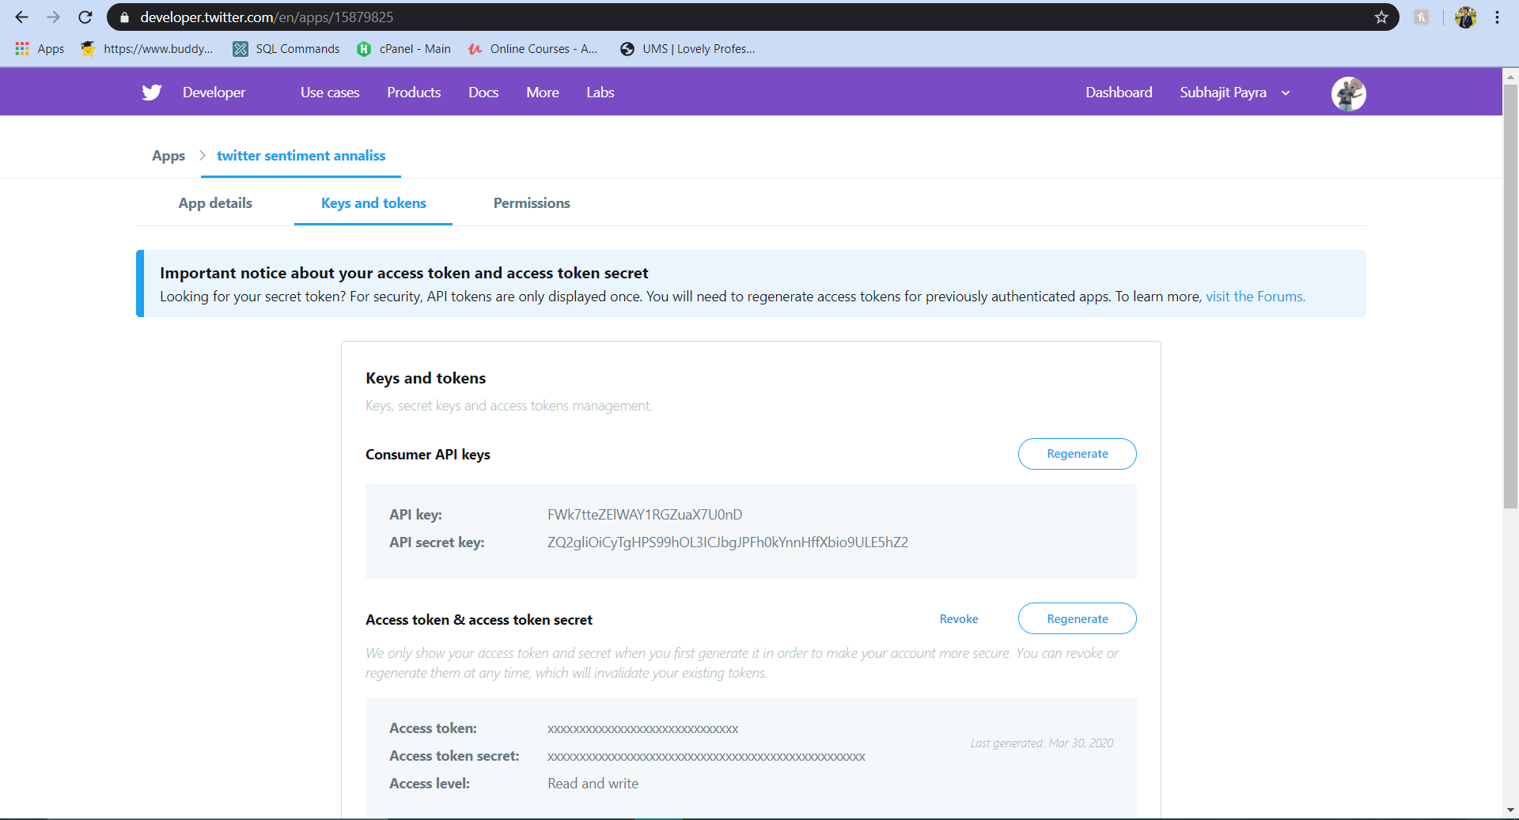

# then we will establish a secure connection to twitter dev console using ‘consumer- key’, ‘consumer-secret’, ‘access-token’ and ‘access-token-secret’ and prints error "Error: Authentication Failed" if is unable to authenticate.

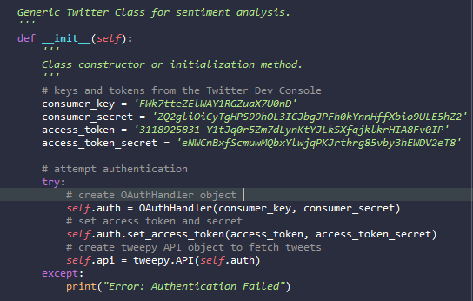

**Step 2**: -

Then it will ask user to enter the product name or details to analyze sentiments of people regarding it.

**Step 3**: -

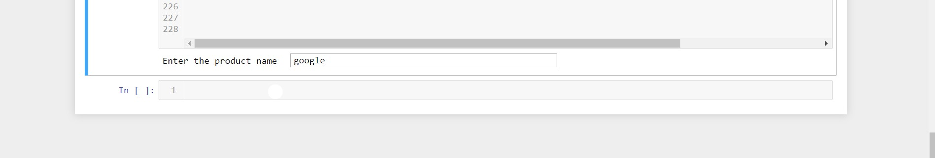Then we will fetch data from the twitter and display the first five tweets

for positive, negative and neutral tweets and also displays retweet if there is any. Then the output would look like below pictures.

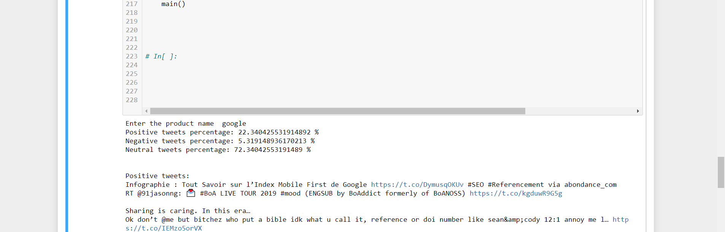

Fig: - Positive tweets acquired

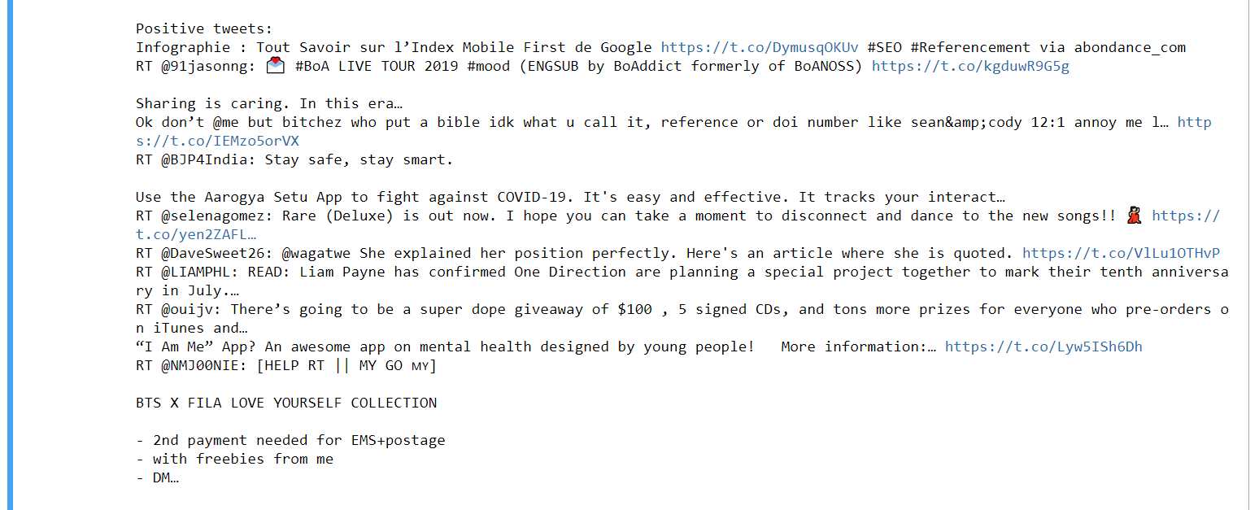

Fig: - Negative tweets acquired

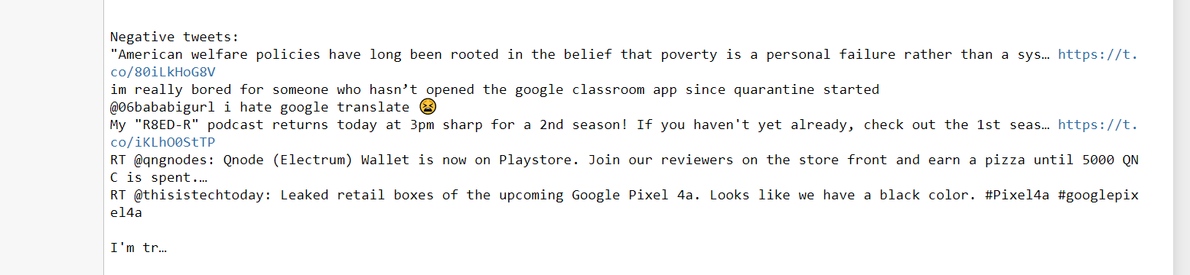

**Storing the data in File:**

Then we r creating the the file as same name of the product if it does not exist. If the file exists then appending the data into the file.

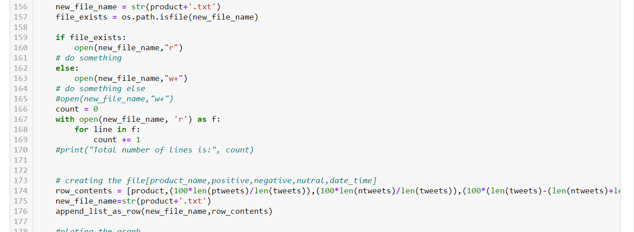

**Analyzed Report from Tweeter**

Fig: - Pie-chart of tweets fig: - Growth Rate of Product

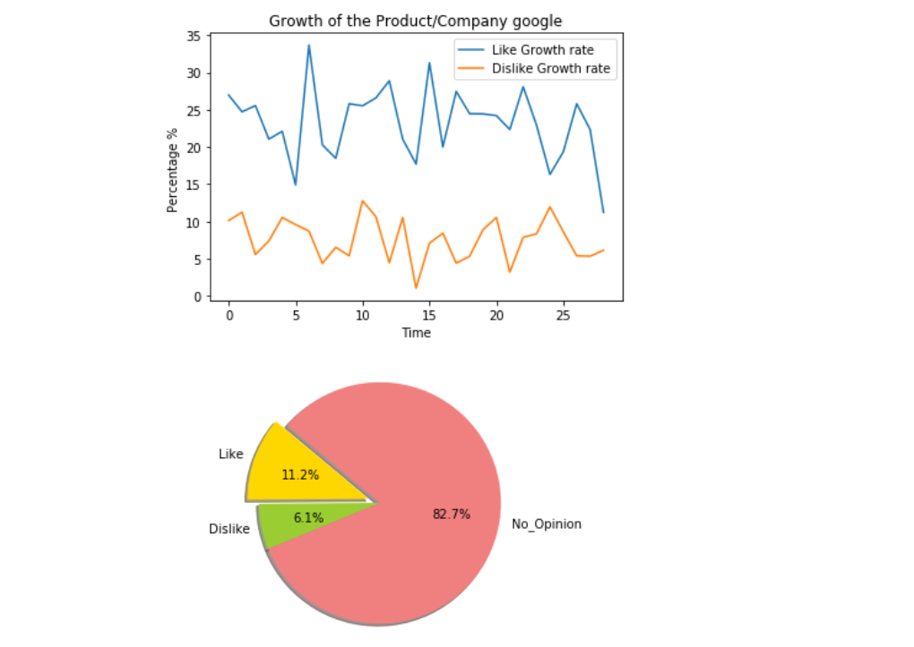

**Application in Marketing Product: -**

These data can be very useful in predicting the growth of product and to estimate the sell of product in coming days. It also helps companies to modify their products for increasing their sell and hence acquire profit.

***Our purpose of Building this Project and Future scope:***

Sentiment Analysis in business, also known as opinion mining is a process of identifying and cataloging a piece of text according to the tone conveyed by it. This text can be tweets, comments, feedback, and even random rants with positive, negative and neutral sentiments associated with them. Every business needs to implement automated sentiment analysis. If you doubt it, here’s a little perspective. The accuracy can never be 100%. And of course, a machine does not understand sarcasm. However, according to a research, people do not agree 80% of the time. It means that even if the machine accuracy does not score a perfect 10, it will still be more accurate than human analysis. Also, when the corpus is huge, manually analyzing is not an option. Hence, sentiment analysis in business is more than just a trend.

**The Role of Sentiment Analysis in Business:**

The applications of sentiment analysis in business cannot be overlooked. Sentiment analysis in business can prove a major breakthrough for the complete brand revitalization. The key to running a successful business with the sentiments data is the ability to exploit the unstructured data for actionable insights. Machine learning models, which largely depend on the manually created features before classification, have served this purpose fine for the past few years. However, deep learning is a better choice as it:

* Automatically extracts the relevant features.
* Helps to scrape off the redundant features.
* Rules out the efforts of manually crafting the features.

At ParallelDots, we have powerful sentiment analysis API that uses deep learning which provides an accurate analysis of the overall sentiment of the given text.

**Sentiment Analysis in Business Intelligence Buildup:**

Having insights-rich information eliminates the guesswork and execution of timely decisions. With the sentiment data about your established and the new products, it’s easier to estimate your customer retention rate. Based on the reviews generated through sentiment analysis in business, you can always adjust to the present market situation and satisfy your customers in a better way. Overall, you can make immediate decisions with automated insights. Business intelligence is all about staying dynamic throughout. Having the sentiments data gives you that liberty. If you develop a big idea, you can test it before bringing life to it. This is known as concept testing. Whether it is a new product, campaign or a new logo, just put it to concept testing and analyze the sentiments attached to it.

**Sentiment Analysis in Business for Competitive Advantage:**

If you are truly catching up with the applications of sentiment analysis in business, you should be open to experimenting with it tactfully. Like I mentioned before, sentiment analysis can be performed on any piece of text. So, why just settle for applying it to your brand? Getting x% negative or positive reviews on a certain product doesn’t make much sense if you don’t have a y% metric to compare it with. Knowing the sentiment data of your competitors gives you the opportunity as well as the incentive to perk up your performance. Sentiment analysis in businesses can be very helpful in predicting the customer trends. Once you get acquainted with the current customer trends, strategies can easily be developed to capitalize on them. And eventually, gain a leading edge in the competition.

**Enhancing the Customer Experience through Sentiment Analysis in Business:**

A business breathes on the gratification of its customers. The experience of the customers can either be positive, negative or neutral. Owing to the internet savvy era, this experience becomes the text of their social posting and online feedback. The tone and temperament of this data can be detected and then categorized according to the sentiments attached. This helps to know what is being properly implemented with regards to products, services and customer support and what needs improvement.

Getting a positive response to your product is not always enough. The customer support system of your company should always be impeccable no matter how phenomenal your services are.

**Sentiment Analysis in Business for Brand Brisking:**

A brand is not defined by the product it manufactures or the services it provides. The name and fame that build a brand majorly depend on their online marketing, social campaigning, content marketing and customer support services. Sentiment analysis in business helps in quantifying the perception of the present and the potential customers regarding all these factors. Keeping the negative sentiments in knowledge, you can develop more appealing branding techniques and marketing strategies to switch from torpid to terrific brand status. Sentiment analysis in business can majorly help you to make a quick transition.

The applications of sentiment analysis in business are plenty and overwhelming. Gaining a greater business value with sentiment analysis depends on what tool you use and how well you use it to your advantage.

Interested in using Artificial Intelligence? You can [SignUp](https://user.apis.paralleldots.com/signing-up?utm_source=blog&utm_medium=banner&utm_campaign=paralleldots_blog" \t "_blank) now for free [ParallelDots](https://www.paralleldots.com/" \t "_blank) account to use Artificial Intelligence at your fingertips

**Working of the Students:**

**SUBHAJIT PAYRA\_reg-no \_11801422:**

1.Creating twitter developer account. 2. Creating new app under twitter developer. 3. Generate API keys . 4. Installing the required library. 5. Writing the complete python program for the project. 6. Writing and finishing the complete report. 7. All the submissions.

**Santosh** : made project report partially**.**

**Nitin:**

**Amarkant:**